**What is a Value Proposition?**

A value proposition is generally a clear and succinct statement that outlines to potential clients and stakeholders a company's unique value-creating features.

A value proposition is a clear statement of the tangible results a customer gets from using your products or services.

A value proposition is an offer to some entity or target in which they get more than they give up , as perceived by them.

A value proposition is the basic reasoning for why people should consider your product or service.

Describes what you do in terms of tangible business results. It draws interest and shares a success story within a few words.

**Importance of a Value Proposition**

Development of a value proposition is a vital part of a company’s [business strategy](https://corporatefinanceinstitute.com/resources/knowledge/strategy/corporate-strategy/). Since the proposition provides a company with a method to influence the decision-making of customers, it is frequently displayed on the company’s marketing materials, such as a website.

Value proposition is a powerful tool to drive sales and build a customer base. Additionally, a perfect and compelling value proposition can advance the effectiveness of the company’s [marketing strategies](https://corporatefinanceinstitute.com/resources/knowledge/other/walmart-marketing-mix/). Generally, it is regarded as the most effective and wide-reaching marketing activity.

### How to Create a Value Proposition

#### Know your customers

#### Understand costs and benefits

#### Don’t forget about competitors

#### Be clear and concise

Design is king! how to identify value proposition for an mvp

how to identify value proposition for an mvp

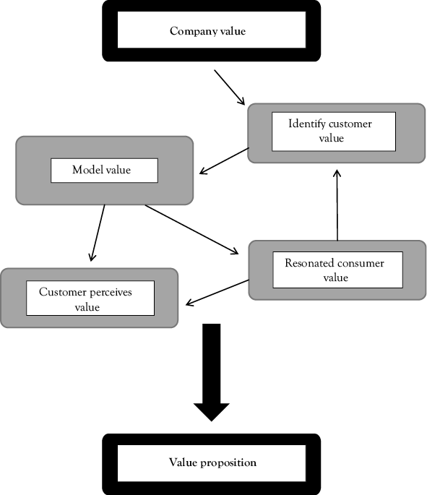

Examples

### ****Slack -**** Slack makes it downright pleasant to work together.

### ****Stripe -**** Payments infrastructure for the internet.

### ****Grammarly -**** Great writing, simplified

### ****WordPress -**** Welcome to the world’s most popular website builder.

### ****Shopify -**** Anyone, anywhere, can start a business.

# **What is Customer Segmentation?**

### Accurate customer segmentation allows marketers to engage with each customer in the most effective way.

## **Customer Segmentation Definition:**

### Customer segmentation is the practice of dividing a company’s customers into groups that reflect similarity among customers in each group. The goal of segmenting customers is to decide how to relate to customers in each segment in order to maximize the value of each customer to the business.

## **The Importance of Customer Segmentation:**

Customer segmentation has the potential to allow marketers to address each customer in the most effective way. Using the large amount of data available on customers (and potential customers), a customer segmentation analysis allows marketers to identify discrete groups of customers with a high degree of accuracy based on demographic, behavioral and other indicators.

Since the marketer’s goal is usually to maximize the value (revenue and/or profit) from each customer, it is critical to know in advance how any particular marketing action will influence the customer. Ideally, such “action-centric” customer segmentation will not focus on the short-term value of a marketing action, but rather the long-term [customer lifetime value (CLV)](https://www.optimove.com/learning-center/customer-lifetime-value/) impact that such a marketing action will have. Thus, it is necessary to group, or segment, customers according to their CLV.

**On what basis or how to carry out the customer segmentation**

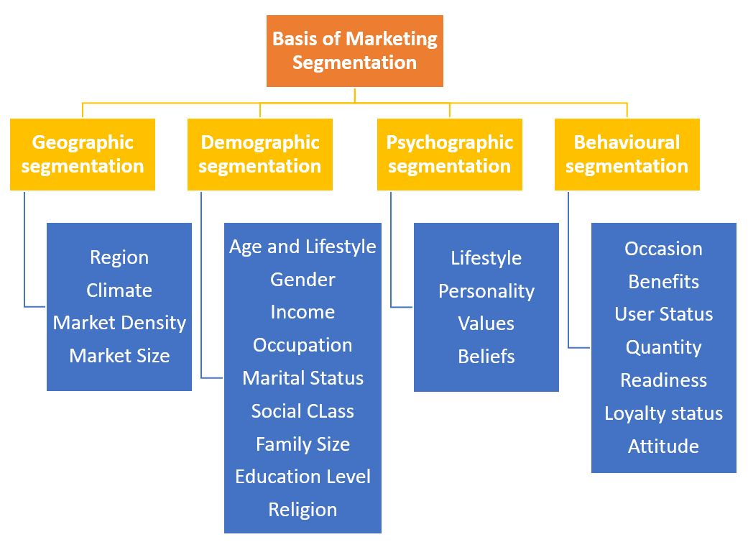

## **5 Types of Customer Segmentation**

Demographic segmentation: gender, age, occupation, marital status, income, etc.

Behavioral Segmentation: actions or inactions, spending habits, feature use, session frequency, browsing history, average order value, content consumption

Geographic Segmentation: country, state, city, town or county.

Psychographic Segmentation: personal attitudes, values, interests, or personality traits.

Technographic Segmentation: preferred technologies, software, and mobile devices.

**how to carry out the customer segmentation**

Identify your customers. ...

Divide customers into groups. ...

Create customer personas. ...

Articulate customer needs. ...

Connect your product to customers' needs. ...

Evaluate and prioritize your best segments. ...

Develop specific marketing strategies. ...

Evaluate the effectiveness of your strategies.

**Examples:**

## Four examples of customer segmentation

Here are a few successful customer segmentation examples that enable valuable customer interactions.

### 1. Don Marler’s Food Cart

Don Marler, founder of family-owned street food truck best known for its mouthwatering cheesesteak sandwiches, generated more revenue after using geographic segmentation in conjunction with [omnichannel marketing](https://manychat.com/blog/omnichannel-marketing-in-2020/).

### 2. Netflix

Netflix uses [behavioral segmentation](https://manychat.com/blog/behavioral-segmentation/" \t "_blank) to deliver customized content to its 158.3 million subscribers every day on an automated basis.

It relies on Machine Learning (ML) to learn about its customers via their behavior on the TV streaming app. Netflix then stores this information to segment customers into groups based on their actions, allowing the media services provider to offer a more personalized customer experience.

### 3. Zinvo Watches

The international timepiece maker, [Zinvo Watches](https://zinvowatches.com/" \t "_blank), collaborated with Dillon Ceglio — [a ManyChat Agency Partner](https://manychat.com/agency/listing/377) — to segment prospects based on their responses to a quiz executed through Messenger. This let the e-commerce business to offer personalized promos and curated offerings that encouraged purchases.

### 4. Porsche

Porsche recently used [psychographic segmentation](https://manychat.com/blog/psychographic-segmentation/), dividing its customers based on their lifestyle choices, personality traits, and values. The company then constructed specific profiles for each list, such as ‘The top gun’ for ambitious and driven individuals who crave power and want to be noticed.

## **Using customer segmentation to grow your business**

* **What is your marketing objective?** (To improve engagement, increase sales, strengthen customer loyalty, bolster your reputation?)
* **What type of customer do you need to target in order to achieve your objective?** (Will you segment them by geographics, demographics, psychographics?)
* **What form will your content take?** (Promotions, offers, educational articles, product videos, surveys.)
* **What are your customers’ preferred means of communication?** (SMS, email, Messenger or all three?)